1. **What is SDLC?**

Ans:- SDLC means a software development life cycle. It’s a multi-step process used by software industry to design, develop, and test software. The main aim of SDLC is to produce high quality software that meet client expectation within time and cost estimates.

1. **What is Software Testing?**

Ans: - Software testing is a process used to identify the completeness, correctness and quality of the developed software.

1. **Write SDLC phases with basic introduction.**

**Ans**: - There are six phases in SDLC

**1.Requirement gathering: -** this is the first phase of SDLC. Here business analyst connects with client and collect requirements from client as per client business need. This information is not clear may be mistake or wrong. This is not easy to understand.

**2. Analysis**: this is second phase of SDLC. Here business analyst and project manager working together and make SRS. In this SRS all requirements are written in specific and clear way anyone can understand

**3.Design**: - this is third phase of SDLC. Here Software architecture, UI/ UX designer working. Thay make software architecture, user interface, design. Tester makes test plan. They solve technical problems also.

**4. Implementation: -** This is forth phase of SDLC. This is coding part. Here mainly all type of fresher, junior, and senior developers working. Thay transfer requirement into code. In this phase actual software development start. They make code as pr the guideline of SRS.

**5.Testing: -** this is fifth phase of SDLC. Here mainly testers working. They test that software as per the client requirement and make sure that software is defect free also check that produce software fulfil the client requirements.

**6. Maintenance: -** this is last phase of SDLC. Maintenance is the process of changing after software has been deployed. Like Resolve bug, improve user experience update etc.

**4.What is SRS ?**

**Ans: -** SRS stands for Software Requirements Specification. It is very important document for software development. It show the functional and non-functional requirement of software development. It serves contract between stakeholders such as client, Developers, and Testers to ensure everyone has a clear understanding of the project requirements and scope.

**5.What is agile methodology?**

**Ans: -** Agile methodologies are iterative and incremental, which means it's known for breaking a project into smaller parts and adjusting to changing requirements.

**6. Explain Phases of the waterfall model.**

**Ans:-** There are six phase in waterfall model. Each phase starts only after previous phase is completed.

1. Requirement gathering
2. Analysis
3. Design
4. Implementation & coding
5. Testing
6. Deployment & maintenance

**7. What is Class?**

**Ans: -** It is collection of data member and member function.

**8. What is object?**

**Ans: -** object gives permission to access functionality of class.

**9. What is Encapsulation?**

**Ans:-** wrapping of data in a single unit.

**10. Write the Phases of Spiral Model.**

**Ans: -** There are four phases in a Spiral Model.

1. Planning
2. Risk Analysis
3. Engineering
4. Customer evaluation

**11.What is inheritance?**

**Ans: -** Deriving the attributes of some other class.

**12. What is polymorphism?**

**Ans: -** one name many forms. There is two types of polymorphism in Java

1. Overloading
2. Overriding

**13. What is Opps?**

**Ans: -** OOPs means Object Oriented programming. OOP uses objects to implement real-world entities. Objects contain data and code are instances of a class.

**14. Basic concept of Opps.**

**Abs: -** 1. Class: - it is collection of data member and member functions.

2.Object: -Object gives permission to access functionality of class.

3. Encapsulation: - wrapping a data in a single unit.

4. Abstraction: -Hiding details showing only essential information.

5.Polymorphism: - One name many firms

6.Inharitance: transfer inherited code from base(parents) class to derived( child) class

**15. Explain working methodology of agile model and also write pros and cons.**

**Ans: -** Agile methodologies are iterative and incremental, which means it's known for breaking a project into smaller parts and adjusting to changing requirements.

**Pros**

1. It’s very realistic approach to develop software.
2. Promotes teamwork and cross training.
3. Resolve requirements in a short time.
4. Suitable in fixed and changing requirements.
5. Easy to manage.

**Cons**

1.Maintainance is complex due to less documentation.

**Draw Use case of online bill payment system (Paytm)**

**Draw Use case on banking system for customers.**

**Draw Use case on Broadcasting System.**

**Draw use case on OTT Platform. (Netflix)**

**Draw use case on E-commerce application**

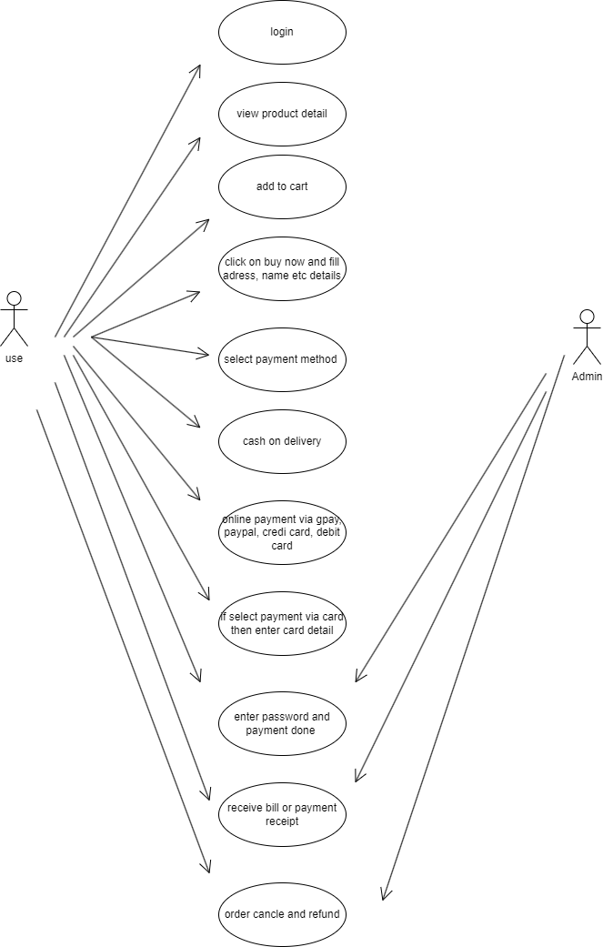

**Draw use case on Online shopping product using payment gateway.**